Airport Management Portal Use Case Document


 | Prepared By / Last Updated By | Prepared By / Last Updated By | Prepared By / Last Updated By
Name | Ajay Sharma | Abirami Kannan | Surendhar Sundaram
Role | Team Member | Team Member | Team Member
Date | 29/3/2019 | 22/5/2019 | 22/5/2019

Table of Contents
1.0 Introduction 3
1.1 Purpose & Scope of the document 3
1.2 Intended Audience 3
1.3 Use case ‘Admin/Manager Registration’ 3
1.3.1 Use case attributes 3
1.3.2 Use Case Model 4
1.3.3 Business Rules 4
1.3.4 UI Requirements 4
1.3.5 UI Field Validations 6
1.4 Use case ‘User Credential Authentication’ 6
1.4.1 Use case attributes 6
1.4.2 Use Case Model 8
1.4.3 Business Rules 8
1.4.4 UI Requirement 8
1.5 Use case ‘Admin Actions’ 10
1.5.1 Use case attributes 10
1.5.2 Use Case Model 11
1.5.3 Business Rules 11
1.5.4 UI Requirement 12
1.6 Use case ‘Manager Actions’ 13
1.6.1 Use case attributes 13
1.6.2 Use Case Model 14
1.6.3 Business Rules 14
1.6.4 UI Requirement 14
2.0 Database Design 16
2.1 Tables Structure 16
3.0 Change Log 19

Introduction

Purpose & Scope of the document
The purpose of this Use case document is to systematically capture requirements for the project and the system to be developed in terms of use cases. Functional use cases are captured in this document. It also serves as the input for the project scoping.

The scope of this document is limited to addressing the use cases from a user, quality, and non-functional perspective.

Intended Audience
Each member of the project team

Use case ‘Admin/Manager Registration’

Use case attributes
Use Case Description:

This use case deals with the capture of user details. The admin and manager here shall be the operator of the system and will be keying in the required information into the system.

Scope:

- Admin/Manager registration

Actors:

- Admin/Manager – the operator

Trigger:

Click ‘Submit’ button in the ‘Admin/Manager Registration’ page

Pre-Condition:

User being able to access the homepage & get redirected to the ‘Admin Registration’ or ‘Manager Registration’ page upon click of ‘Admin-Register’ or ’Manager-Register’ Button.

Post Condition:
Admin/Manager is on the registration page & submit details.

Flow of Events:
User at homepage → Click respective Register button → admin/manager is in the registration page → User details are submitted and added onto the database
Primary Scenario:
A new user – is able to click Register button and able to provide his details and get enrolled in the system

Forgot password--if the manager can forgot the password .Then click forgot password link in the home page .The link can be redirect to security question page .The security question and answer is already set by the user during registration .The manager can enter the security question and answer correctly then the user can change the password.

Use Case Model
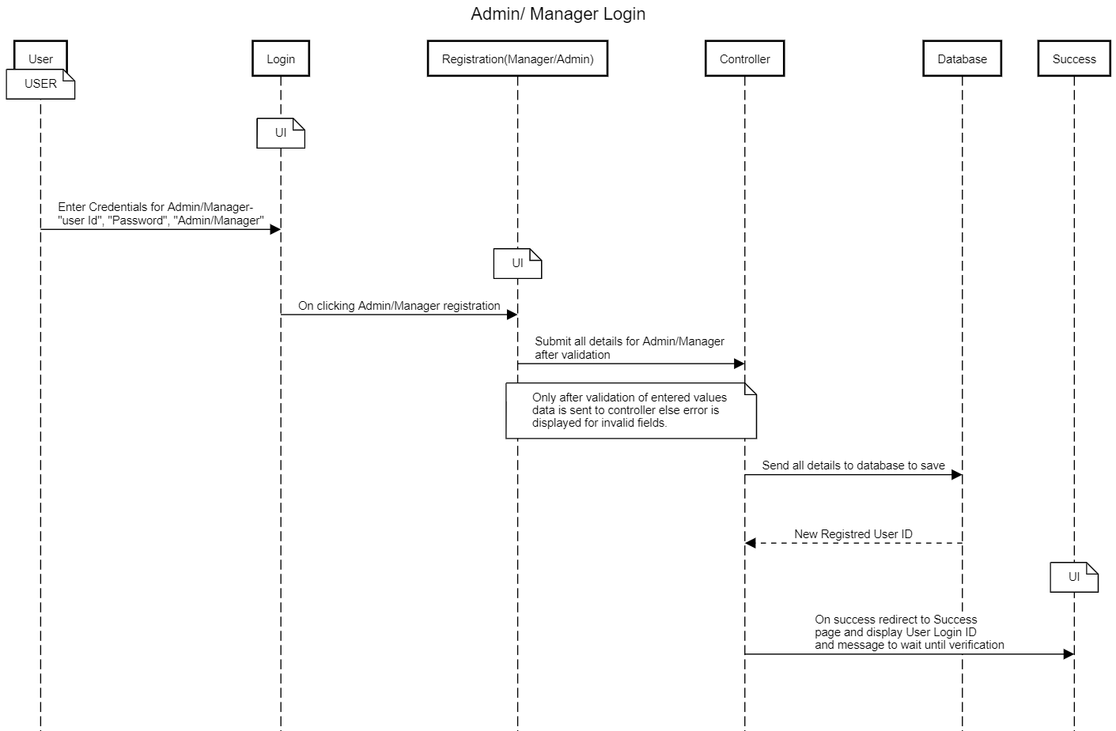

Business Rules

Business rules should be defined using the following attributes: -

- When the user clicks on the registration link, it should re-direct to registration form.
    - User needs to fill some of the basic attributes/fields as mentioned below in requirement: First Name, Last Name, Age, Gender, Contact Number, Email id, Password, Associate ID
- Clicking ‘Submit’ should validate the datatype constraints for each field
- Post-successful field level validation, save the information in the database
- Upon saving the information in the database, display the message ‘Your details are submitted successfully’.

UI Requirements

Here is a prototype on how the homepage should look like.

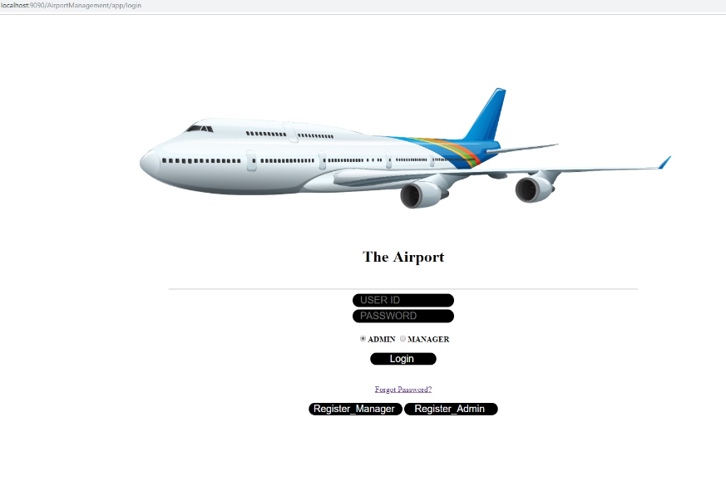

Here is a prototype on how the ‘ Manager Registration’ page should look like.

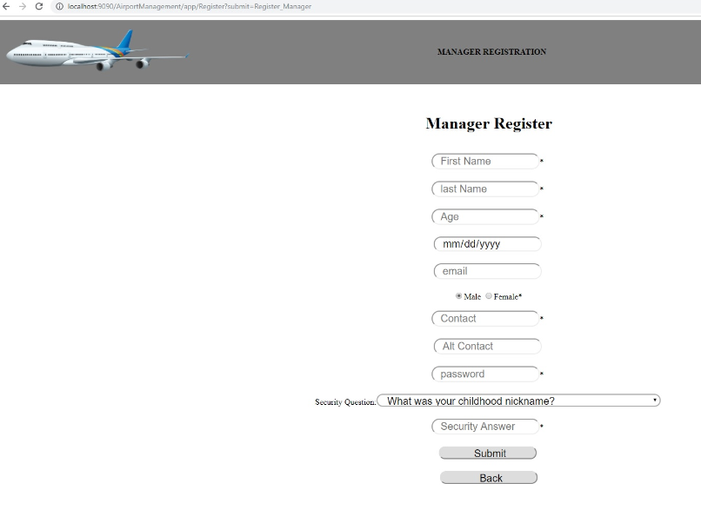

Here is a prototype on how the ‘ admin Registration’ page should look like.

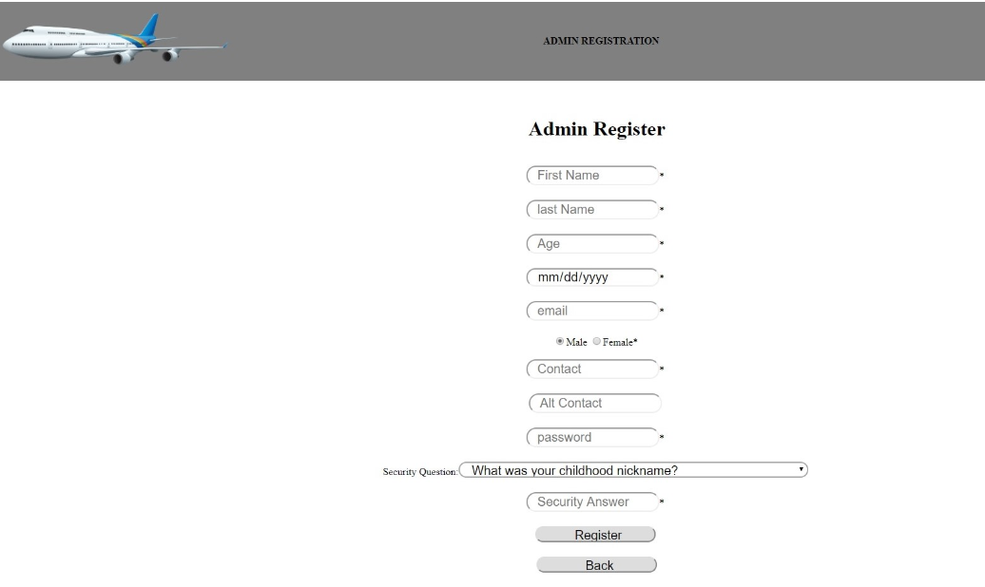

Here is a prototype on how the forgot password page should look like.

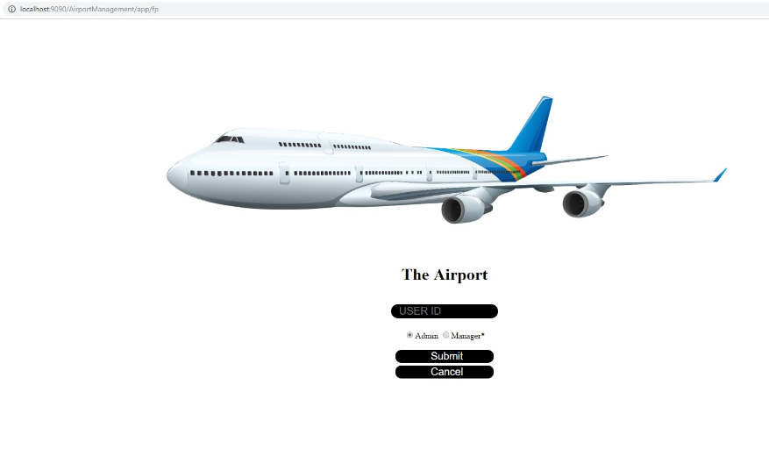

Here is a prototype on how the reset password page should look like.

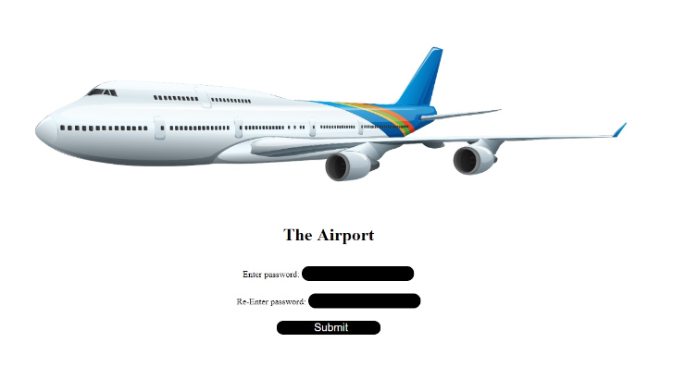

UI Field Validations
Please refer to the below requirements for field level validations:

- All fields are mandatory.
- The Email ID format must be checked. (For ex. test@testmail.com.)

Use case ‘User Credential Authentication’

Use case attributes
Use Case Description:

This use case deals with the authentication of the user credentials. The ‘user’ here shall be the operator of the system and will be performing the required tasks

Scope:

- User credentials authentication

Actors:

User – the operator

Trigger:

Click ‘Login’ link, after keying in ‘user ID’, ‘Password’ fields and user profile radio buttons for ‘Admin’ and ‘Manager’

Pre-Condition:

User being able to access the homepage

Post Condition:

User is in the dashboard page and is able to perform the allowed tasks.

Flow of Events:

Admin at homepage → Key in ‘User ID’ & ‘Password’ field and select ‘Admin’ as profile→ User credentials are validated → Admin dashboard is displayed
Or
Manager at homepage → Key in ‘User ID’ & ‘Password’ field and select ‘Manager’ as profile→ User credentials are validated → Manager dashboard is displayed

Primary Scenario:
A registered user – is able click ‘Login’ link, after keying in ‘User ID’ & ‘Password’ field and get his credentials authenticated with the existing database entry.

Alternative Scenario:
A registered user – is able click ‘Login’ link, after keying in ‘User ID’ & ‘Password’ field and unable to get his credentials authenticated. The user is presented with relevant error messages:

- Invalid User ID
- Incorrect Password
- Account not verified

Use Case Model
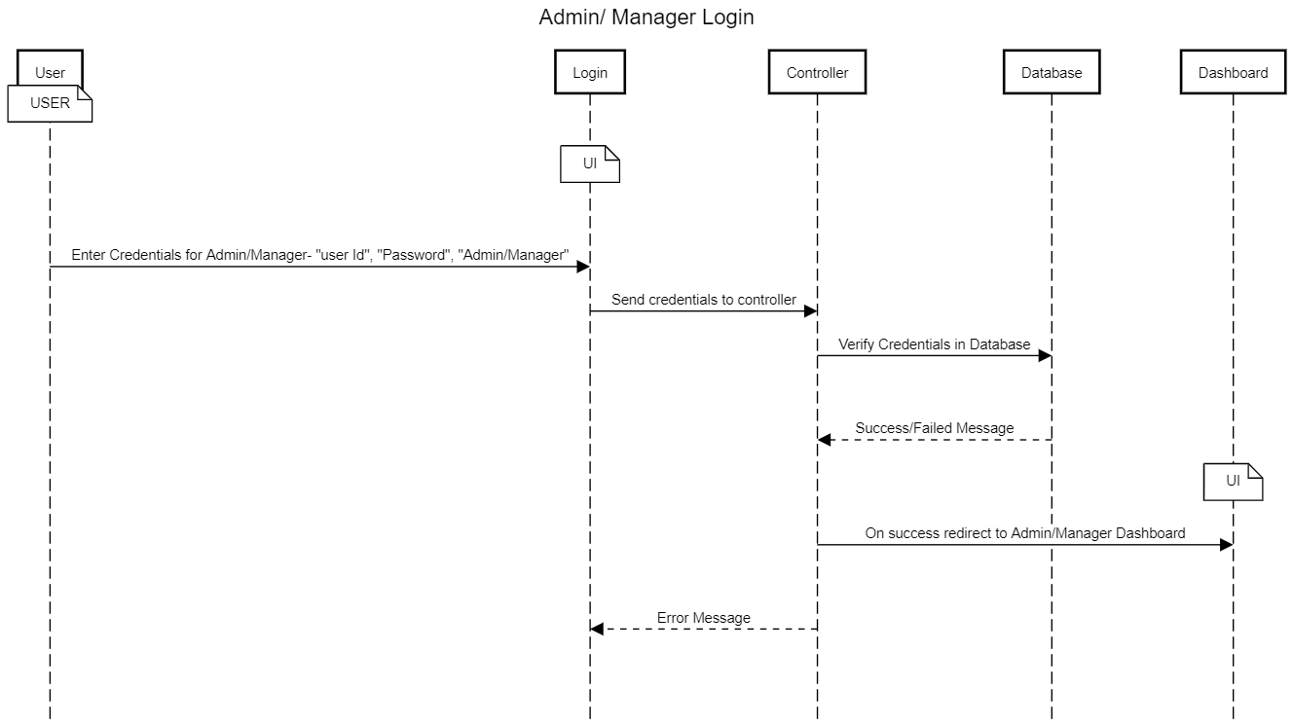

Business Rules
Business rules should be defined using the following attributes: -

- A registered user – is able click ‘Login’ link, after keying in ‘user ID’, ‘Password’ field & selecting his profile and get his credentials authenticated with the existing database entry.

UI Requirement

Here is a prototype on how the Admin Dashboard should look like.

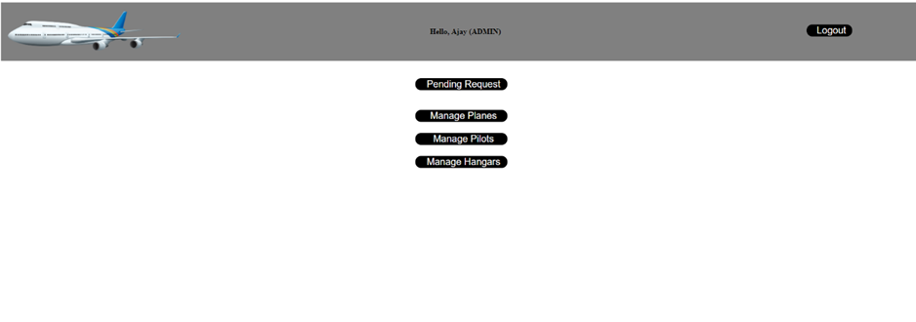

Here is a prototype on how the Manager Dashboard should look like.



Use case ‘Admin Actions’

Use case attributes
Use Case Description:

This use case deals with the actions performed by the Admin. The ‘user’ here shall be the Admin of the system and will be performing the required tasks

Scope:

- Display and accept new user requests.
- Display, add or edit plane details.
- Display, add or edit pilot details.
- Display, add or edit hangar details.

Actors:

User – the Admin

Trigger:

Click ‘Pending Requests’ button to display pending requests in a new page.
Click ‘Manage Planes’ to display all plane details in new page.
Click ‘Manage Pilots’ to display all pilot details in a new page.
Click ‘Manage Hangars’ to display all hangars in a new page.
Click ‘Accept’ on pending requests to accept a request.
Click ‘Edit’ on manage pages to edit details of particular plane, pilot or hangar.
Click ‘Add new’ button on manage pages to add new hangar, plane or pilot.

Pre-Condition:

User being able to access the Dashboard.

Post Condition:

User is in the dashboard page and is able to perform the allowed tasks.

Flow of Events:

Admin at Dashboard → Selects one of given option→Redirected to selected page

Primary Scenario:
A registered Admin – is able to select given options from dashboard according to work requirement.

Use Case Model
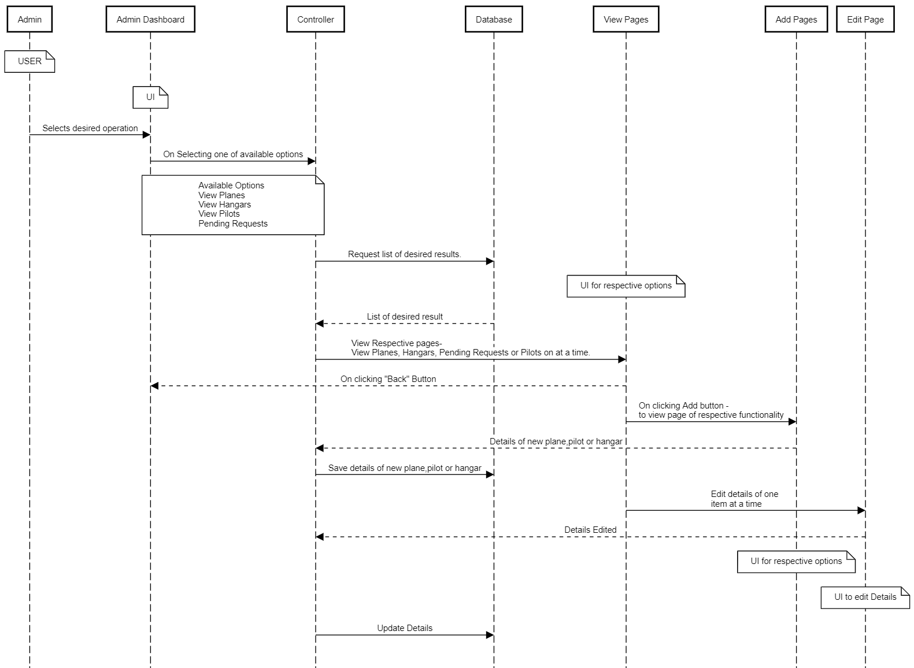

Business Rules
Business rules should be defined using the following attributes: -

- A Admin – is able to view, edit or add planes, pilots and hangars in the system.

UI Requirement
Here is a prototype on how the view page should look like
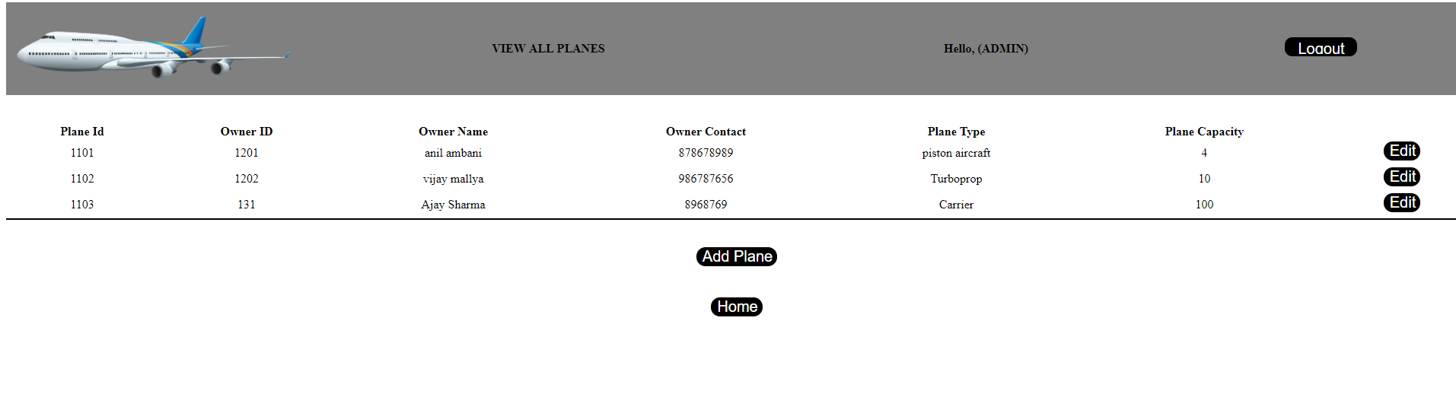

Here is a prototype on how the add page should look like

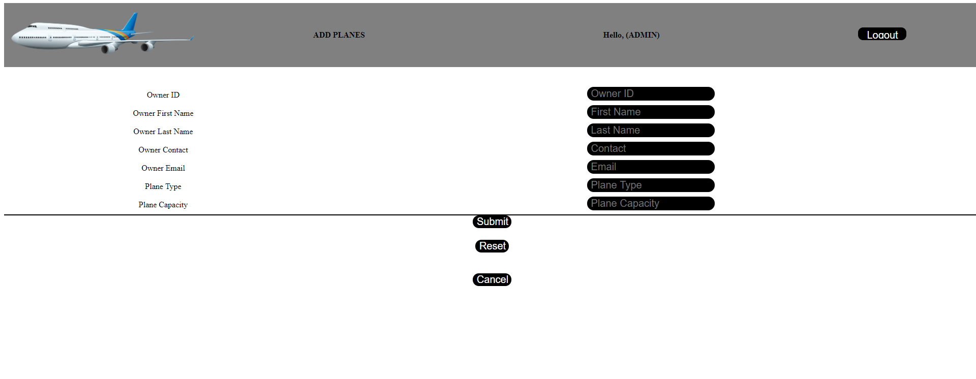
Here is a prototype on how the edit page should look like

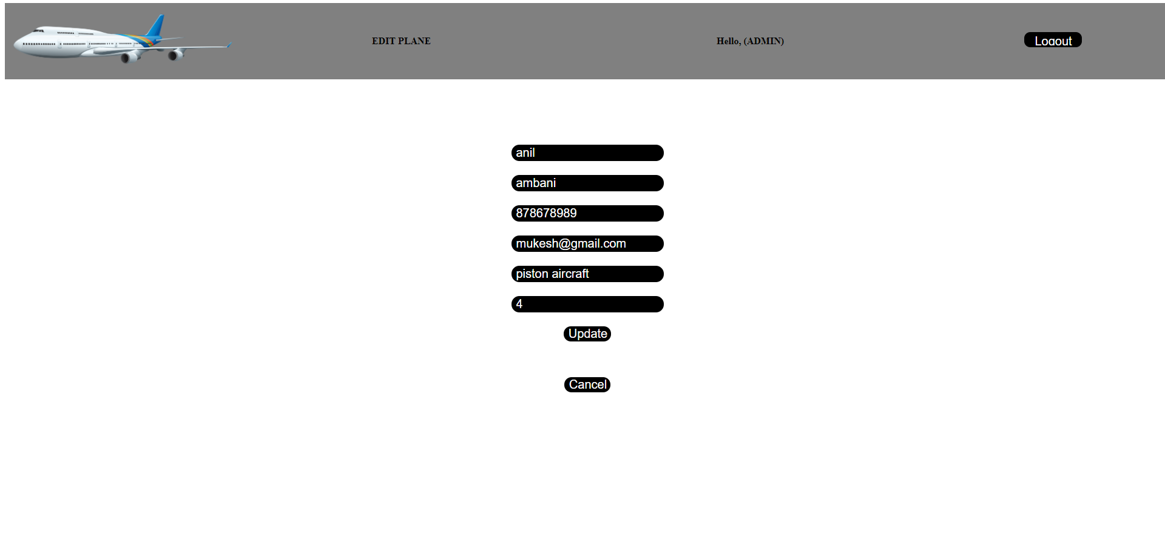

Use case ‘Manager Actions’

Use case attributes
Use Case Description:

This use case deals with the actions performed by the Manager. The ‘user’ here shall be the Manager of the system and will be performing the required tasks

Scope:

- Display Hangar status as available and unavailable.
- Assign Hangars to planes.

Actors:

User – the Manager

Trigger:

Click ‘Hangar Status’ on manager dashboard to view all hangars with status.
Click ‘Assign Hangar’ button on manager dashboard to assign available hangars to planes.
Click ‘Unassign’ button on hangars to unassign specific hangar.

Pre-Condition:

User being able to access the Dashboard.

Post Condition:

User is in the dashboard page and is able to perform the allowed tasks.

Flow of Events:

Manager at Dashboard → Selects one of given option→Redirected to selected page

Primary Scenario:
A registered Manager – is able to select given options from dashboard according to work requirement.

Use Case Model
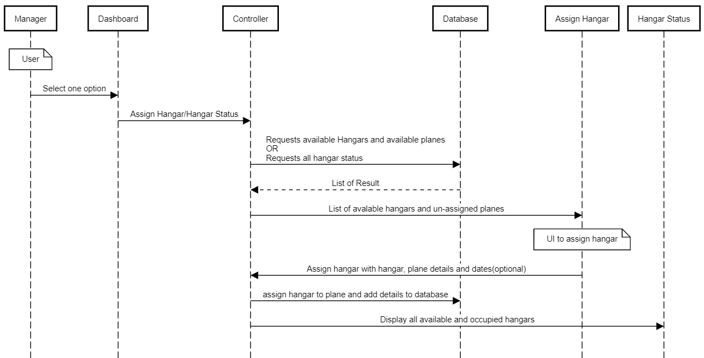

Business Rules
Business rules should be defined using the following attributes: -

- A Manager– is able to view hangar status, assign hangars to planes and un-assign hangars.

UI Requirement
Here is a prototype on how the Hangar status page should look like
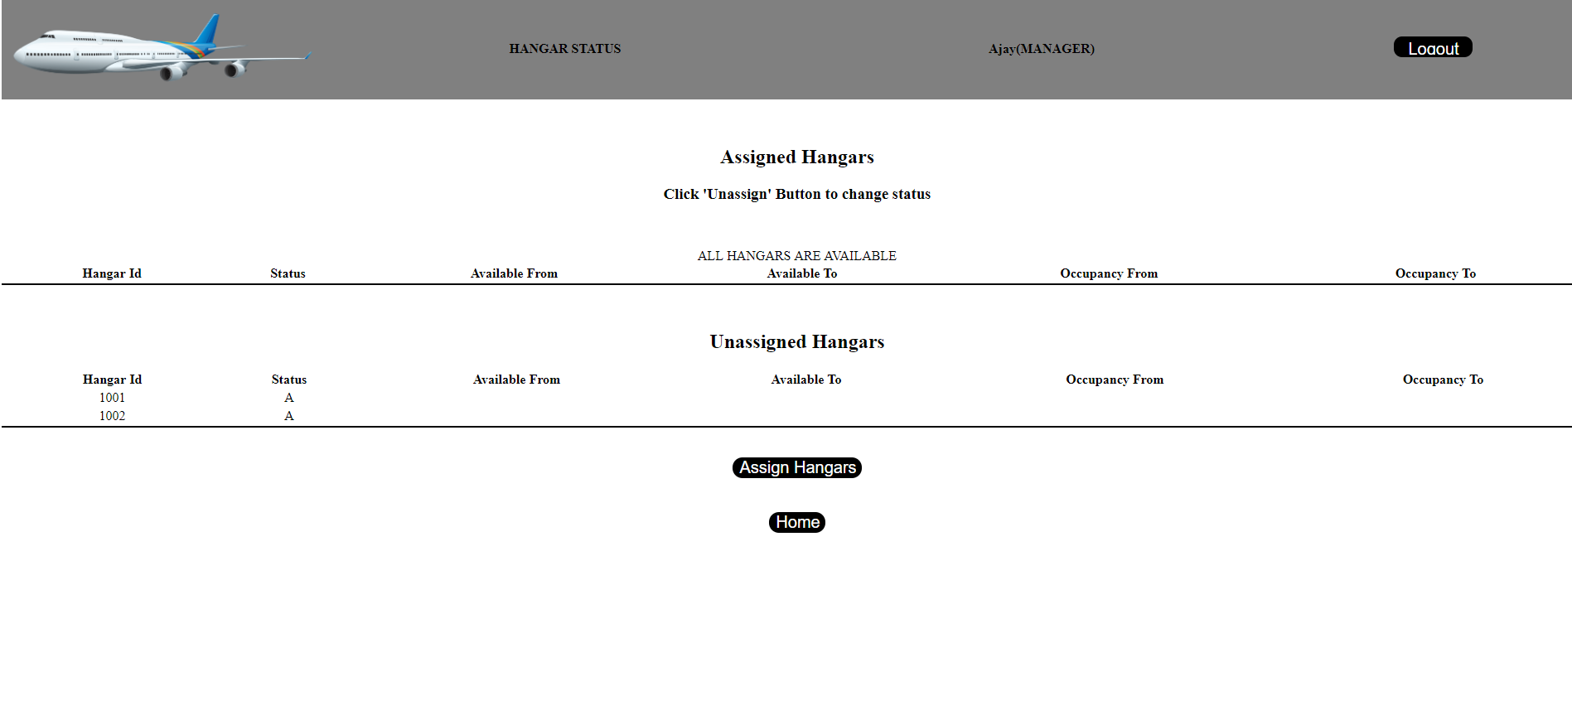

Here is a prototype on how the assign hangar page should look like
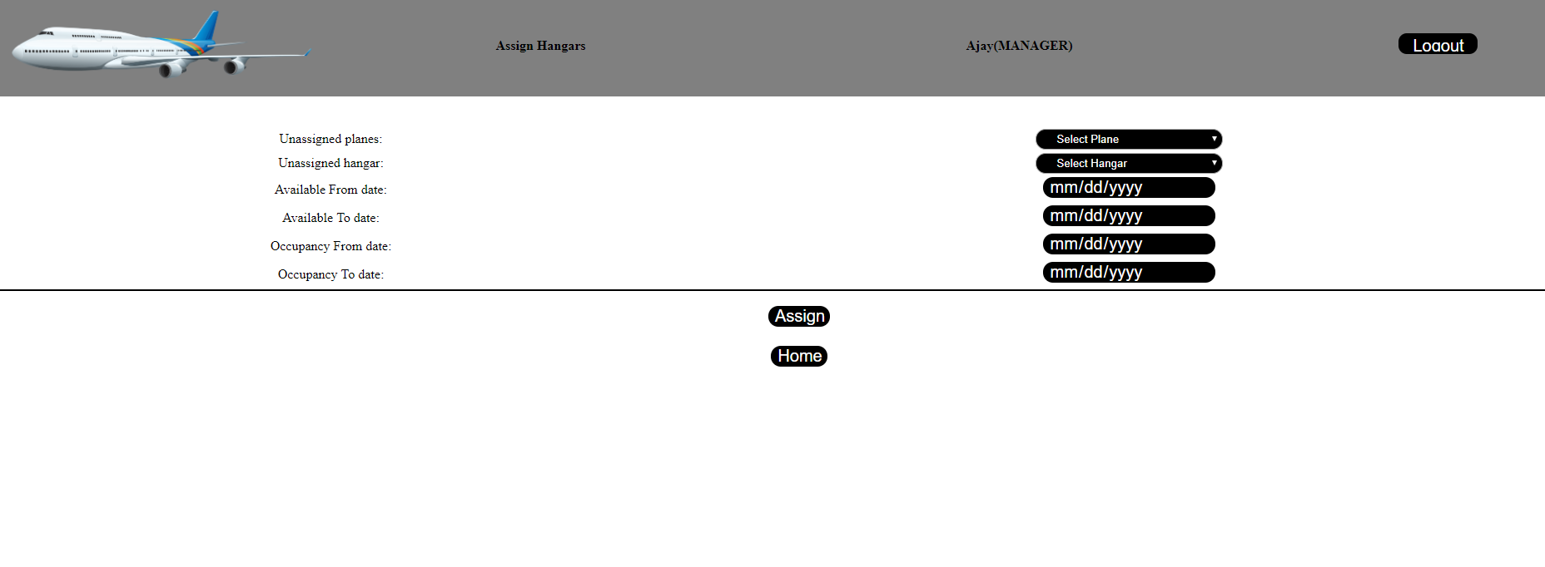

Database Design

Tables Structure

Admin Details:

Field Name | Field Type | Data Type | Mandatory | Possible Values
Admin ID | Text(10) | Alphabetic | Yes | System Generated
First Name | Text(50) | Alphabetic | Yes
Last Name | Text(50) | Alphabetic | Yes
Age | Numeric(2) | Numeric | Yes
Gender | Text(10) | Alphanumeric | Yes | Male, Female
DoB | Text(10) | Alphanumeric | Yes
Contact Number | Text(10) | Numeric | Yes
Alt Contact Number | Text(10) | Numeric | No
Email ID | Text(50) | Alphanumeric | Yes

Manager Details:
Field Name | Field Type | Data Type | Mandatory | Possible Values
Manager ID | Text(10) | Alphabetic | Yes | System  Generated
First Name | Text(50) | Alphabetic | Yes
Last Name | Text(50) | Alphabetic | Yes
Age | Numeric(2) | Numeric | Yes
Gender | Drop Down | NA | Yes | Male, Female
DoB | Text(10) | Alphanumeric | No
Contact Number | Text(10) | Numeric | Yes
Alt Contact Number | Text(10) | Numeric | No
Email ID | Text(50) | Alphanumeric | No
Password | Text(15) | Alphanumeric | Yes

Plane details:
Name | Field Type | Data Type |  | Mandatory | Possible Values
Plane ID | Text(8) | Numeric |  | Yes | System generated
Owner ID | Numeric(10) | Numeric |  | Yes
Owner first Name | Text(100) |  | Alphabetic | Yes
Owner Last name | Text(100) |  | Alphabetic | Yes
Owner Contact number | Numeric (10) |  | Numeric | Yes
Owner Email | Text (50) |  | Alphanumeric | Yes
Plane Type | Text (10) |  | Alphanumeric | Yes
Plane capacity | Numeric(3) |  | Numeric | Yes

Pilot Details:
Field Name | Field Type | Data Type | Mandatory
Pilot ID | Auto-generated(8) | Numeric | Yes
License Number | Text(100) | Alphabetic | Yes
Address Line 1 | Text(100) | Alphanumeric | Yes
Address Line 2 | Text(100) | Alphabetic | Yes
City | Text(50) | Alphabetic | Yes
State | Text(50) | Alphabetic | Yes
Zip Code | Text(10) | Numeric | Yes
SSN | Numeric(9) | Numeric | Yes

Hangar Details:
Field Name | Field Type | Data Type | Mandatory | Possible Values
Hangar ID | Text(8) | Numeric | Yes | System  Generated
Manager ID | Text(100) | Alphabetic | Yes
Manager Address Line 1 | Text(100) | Alphanumeric | Yes
Manager Address Line 2 | Text(100) | Alphanumeric | No
City | Text(50) | Alphabetic | Yes
State | Text(50) | Alphabetic | Yes
Zip Code | Text(10) | Numeric | Yes

Hangar Status:
Field Name | Field Type | Data Type | Mandatory | Possible Values
Hangar ID | Text(8) | Numeric | Yes
Manager ID | Text(100) | Alphabetic | Yes
Status | Text(1) | Alphabetic | Yes | A - Available  O - Occupied
Occupancy From date | Text(10) | Alphanumeric | No
Occupancy till date | Text(10) | Alphanumeric | No
Available from date | Text(10) | Alphanumeric | No
Available till date | Text(10) | Alphanumeric | No

Change Log
Version Number | Changes Made
V1.0 | Initial baseline created on 16-04-2019 by Ajay Sharma
V1.1 | Forgot password added on 22/5/2019 by Surendhar Sundaram  And Abirami Kannan

